Type of funding | Yes | Code/letter
2yr
3yr
30hrs

Deposit paid
Birth certificate seen

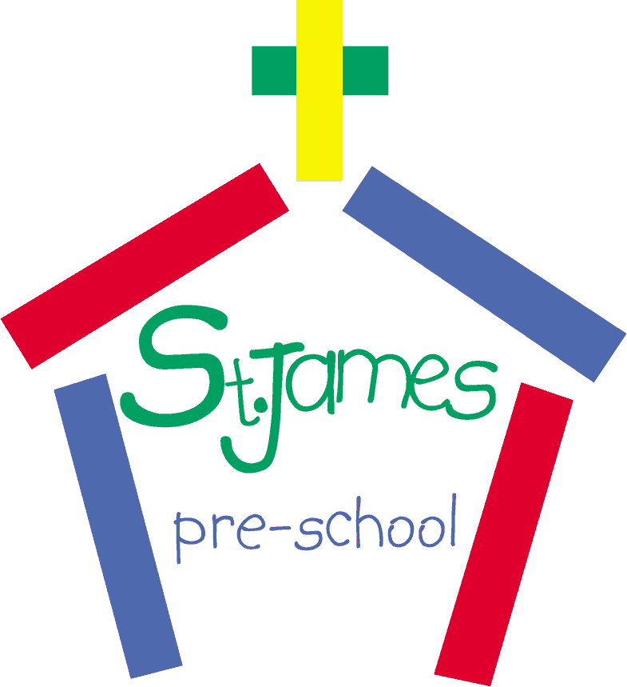

REGISTRATION FORM

DATE OF REGISTRATION: ……...........................……………………………....................................

CHILD’S NAME: ……............................……………………………………………...............................

DATE OF BIRTH: ........................………………………………………………….................................

ADDRESS: ………..................................................................…………………..................................

...........................................................................................................................................................

...........................................................................................................................................................

PARENT/CARER NAME: (Mr/Mrs/Ms/Miss) ..................................…………….................................

...........................................................................................................................................................

PARENT/CARER SIGNATURE: ………......………………………………………................................

CONTACT ADDRESS IF DIFFERENT: …..………………………………………….............................

...........................................................................................................................................................

TELEPHONE (DAY): …………………………………………………………………...........................

(EVENING): …………………………………………………………………..................

(MOBILE): ……………...................................……………………………..................

(EMAIL): ……………………………………………………………………….................

PREFERENCES: (i.e. please specify your preference for which days / am or pm or either sessions / which term or month you would like your child to start.) Please note allocation of these is subject to availability.

...........................................................................................................................................................

HOW / WHERE DID YOU HEAR ABOUT US?

...........................................................................................................................................................
There is a £5 registration fee for any new children wanting to join the waiting list. This is payable by cash or cheque to St. James’ Church Pre-School. Please post/drop this in directly to the Pre-School.

